Running the Playwright scripts using pytest:
- Using a terminal on PyCharm, type the following in the tests folder of your project:
C:\Users\c_p_r\PycharmProjects\pythonProject1\tests> pytest -v --html=quarrie__regression_report.html --self-contained-html
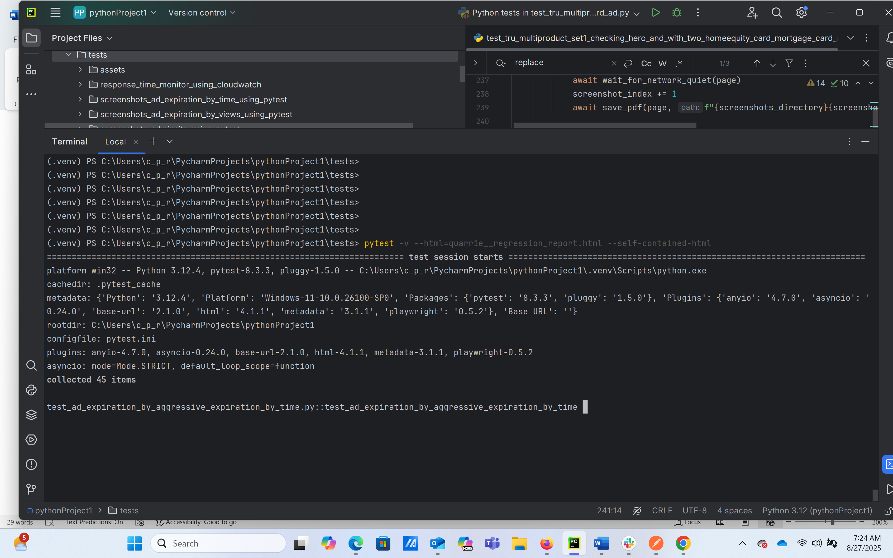
Run make take about 30 minutes and will show how many tests passed and failed

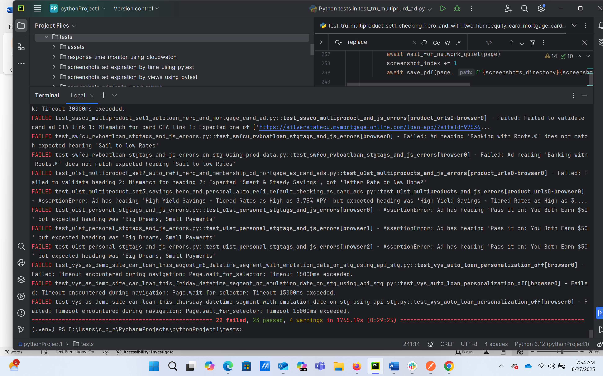

- Open the generated HTML report and triage the failures
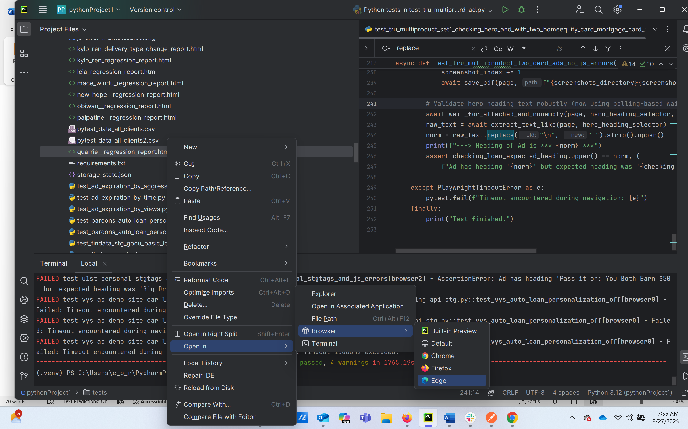

NOTE:
some are timeouts, some are due to changes in the ads, some are locator changes

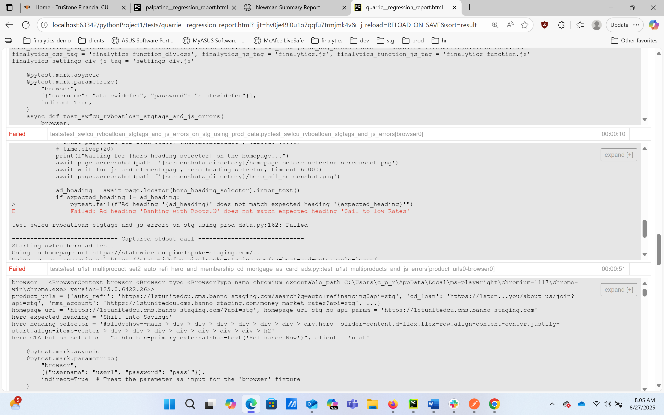

Screenshots for scripts are generated in folders under tests folder:
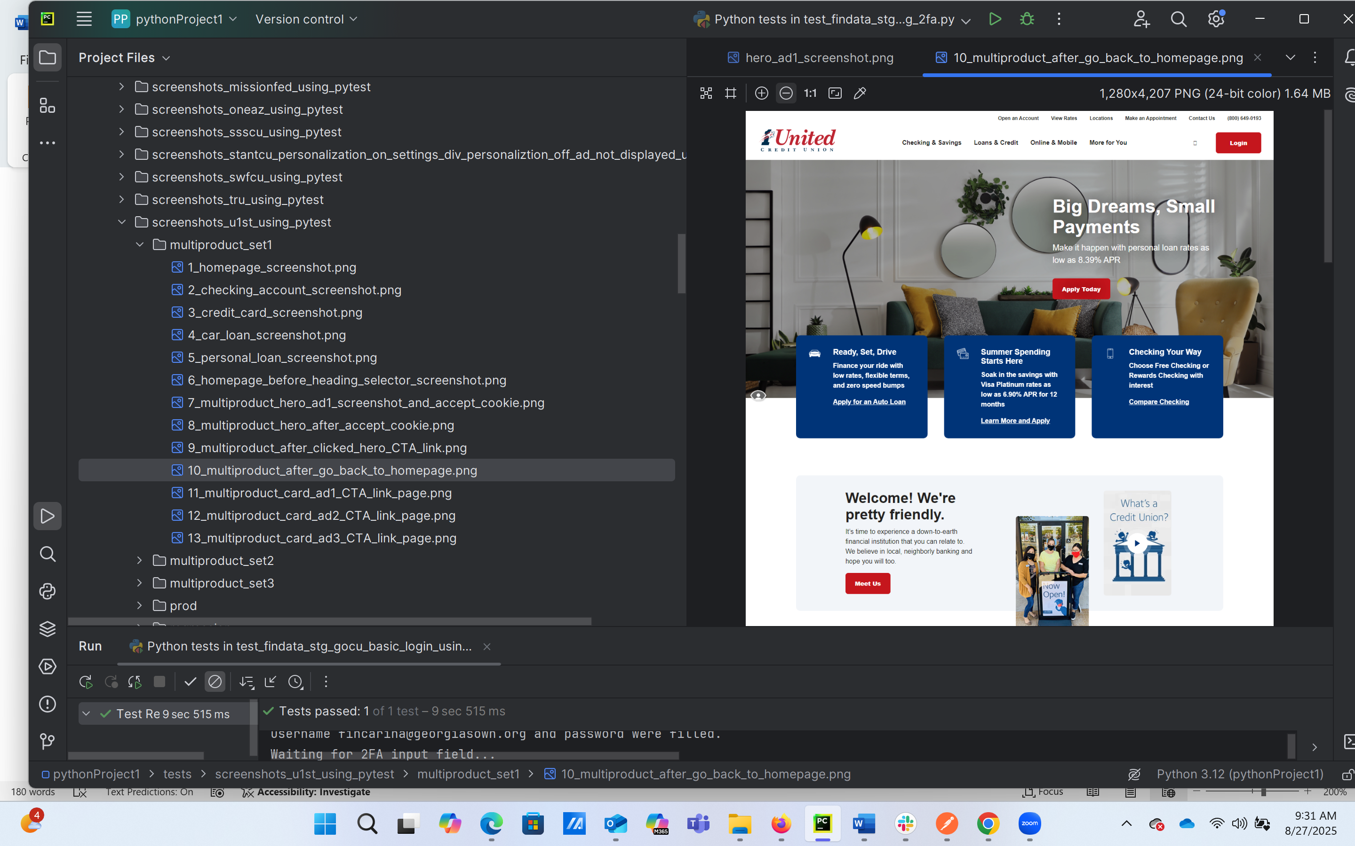

NOTE: 15 of the 22 are due to the admin sites tests which uses 2FA and only works when run one at a time (can put in a folder outside the tests folder and run manually also)

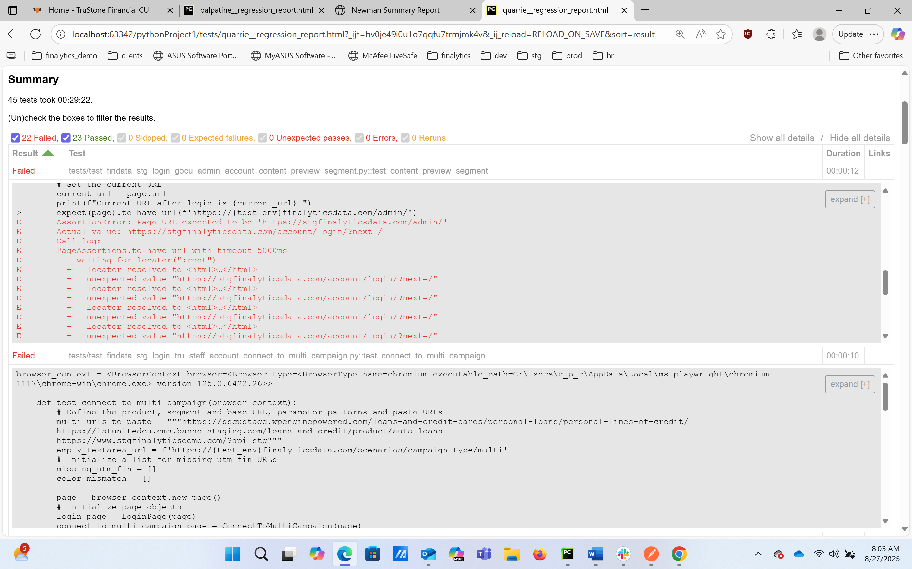
To run the admin site scripts, right click and select “run” as shown
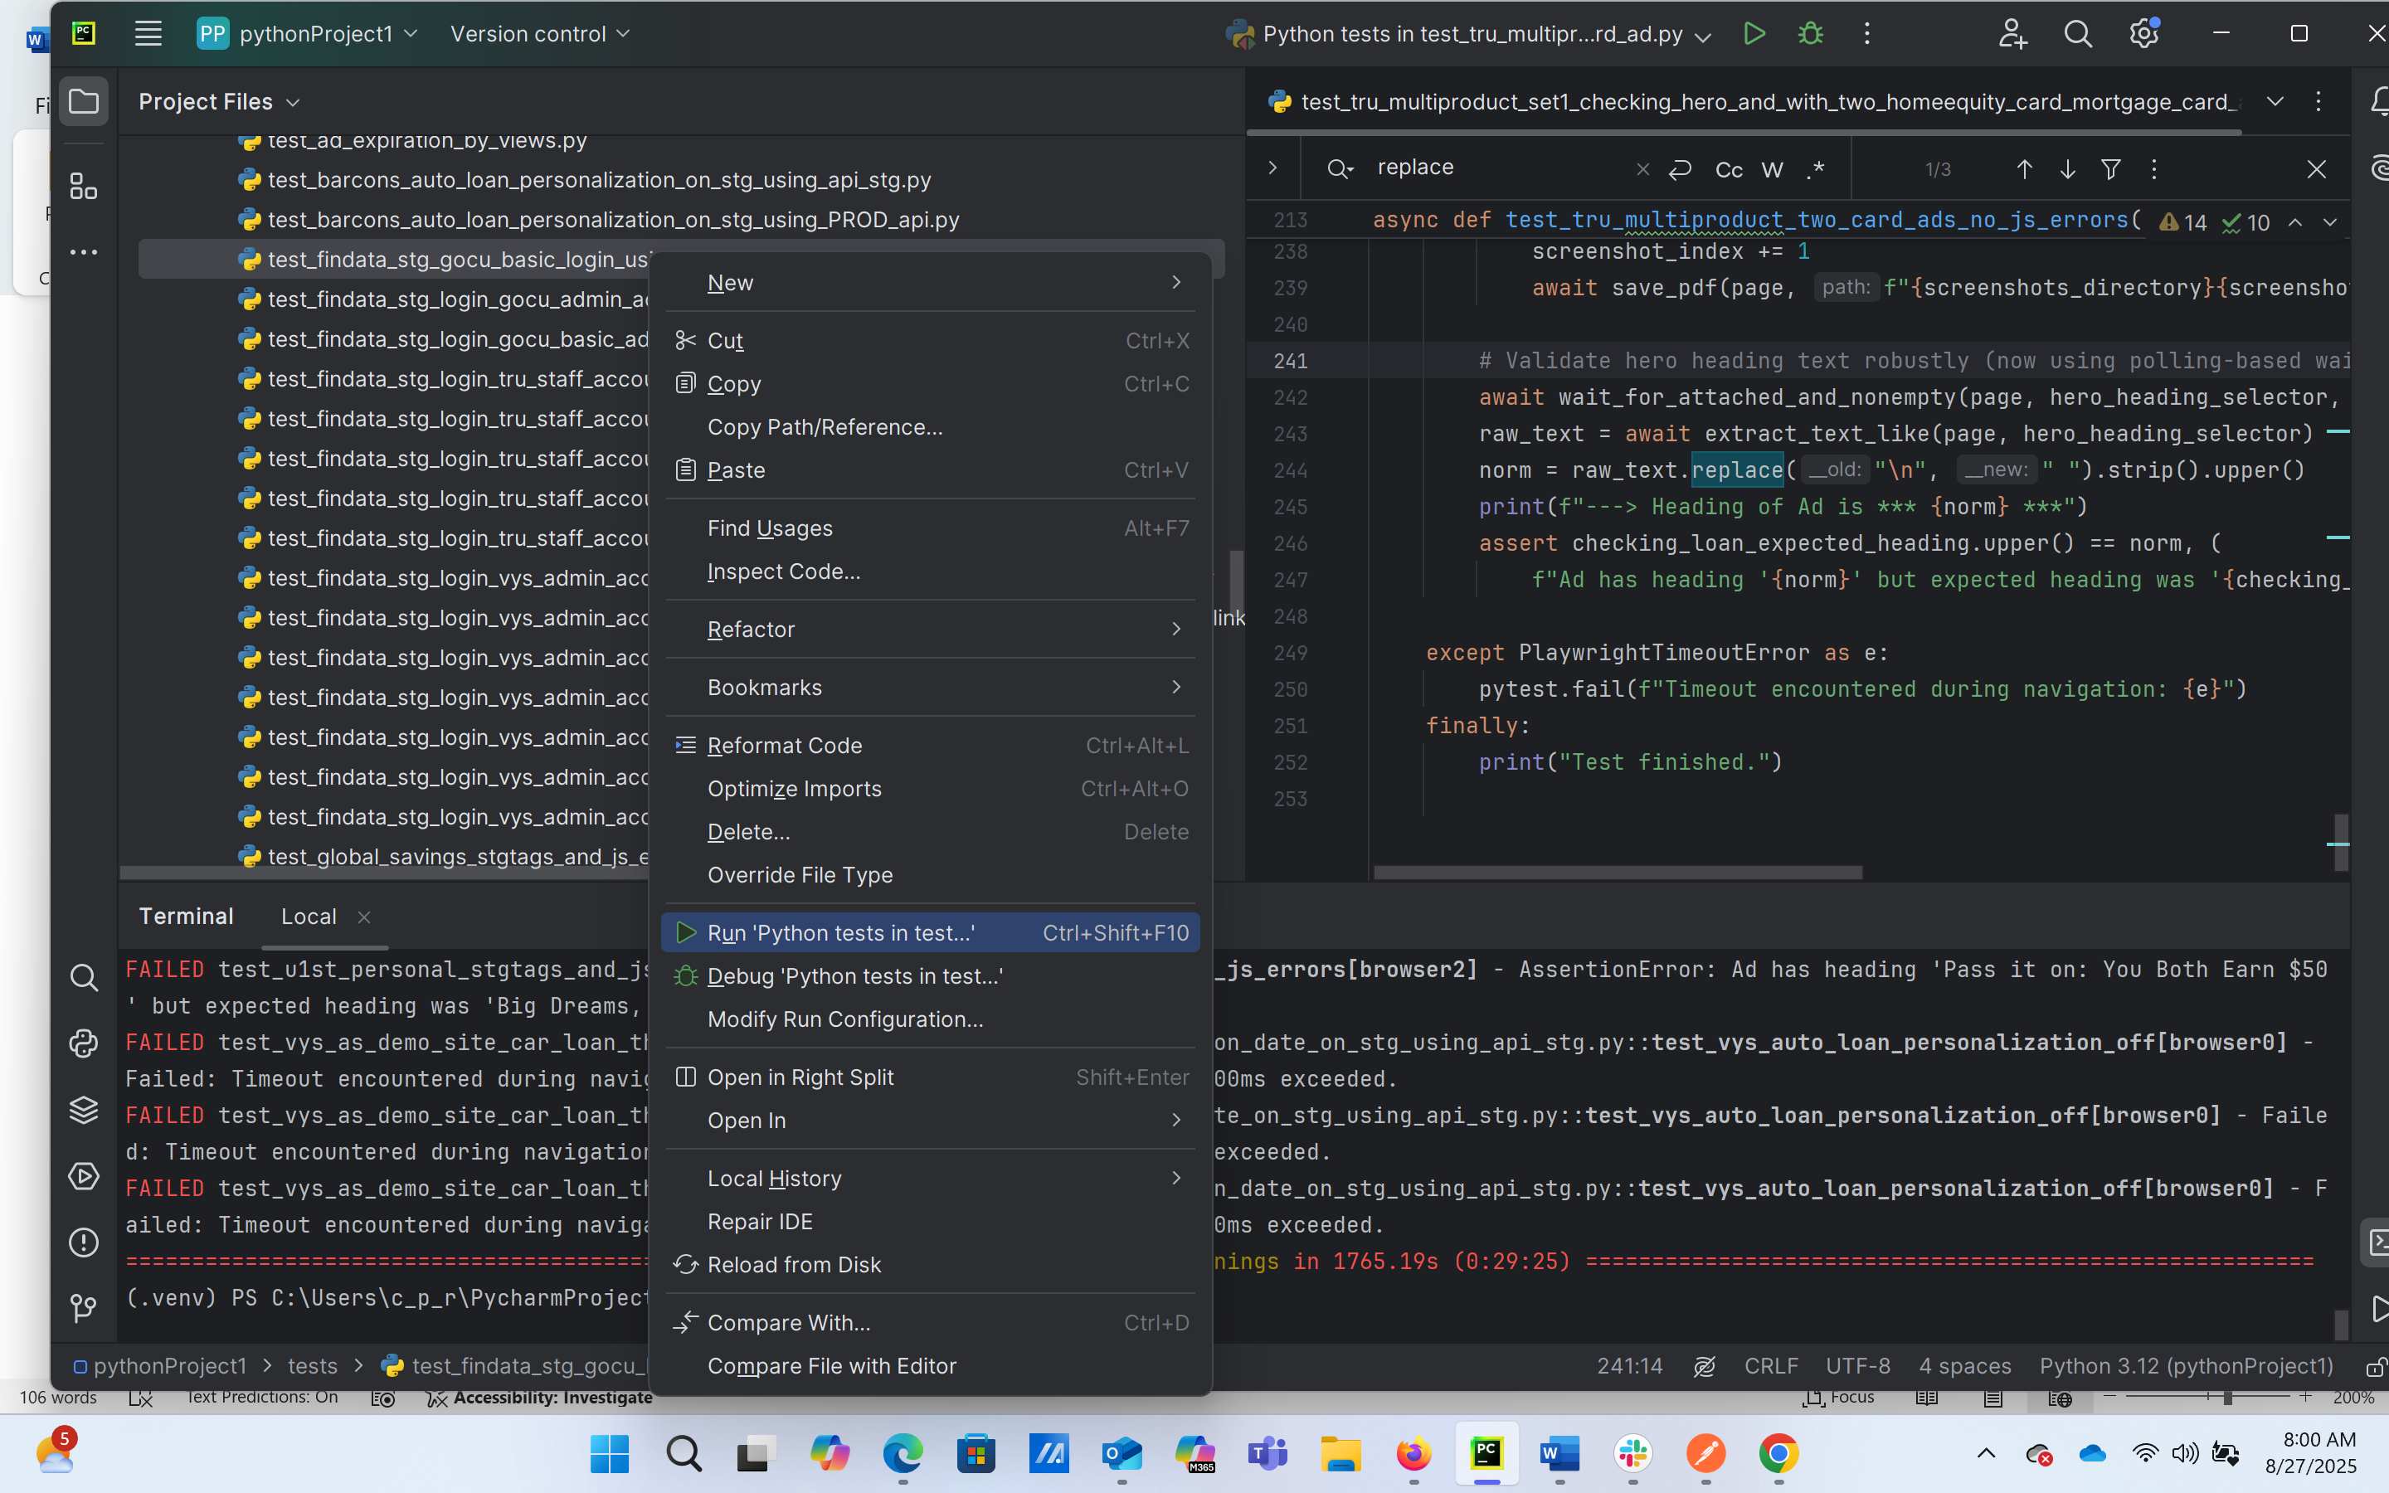
NOTE:
Test passes as shown and 2FA entered
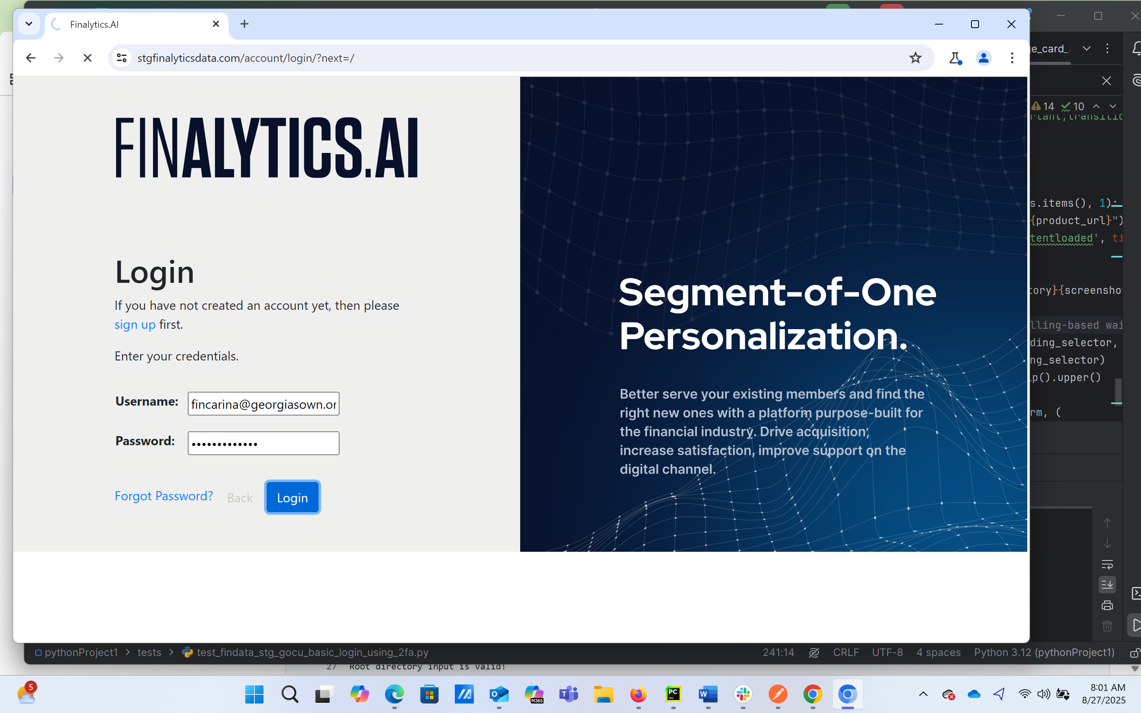
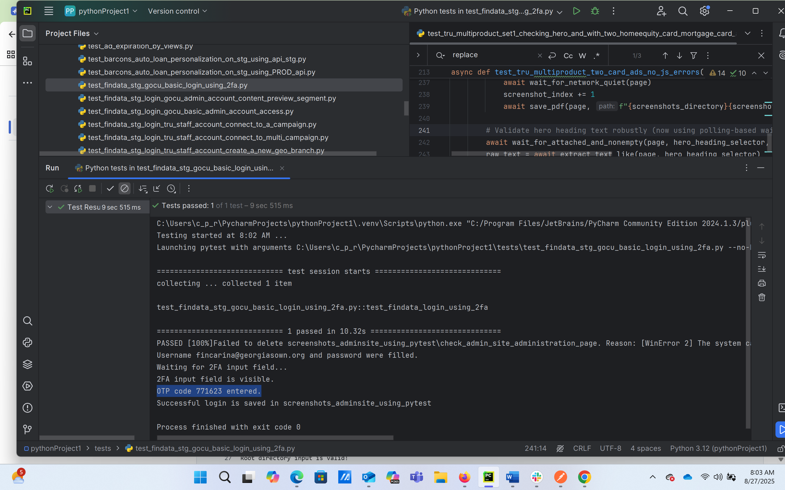

NOTE:
The admin site tests uses a .env in the root project folder (C:\Users\c_p_r\PycharmProjects\pythonProject1) which contains the environment variables of the username and password in the scripts and there is a .gitignore file to ensure that this doesn’t get committed in github

